## Lab 2 Yanzhang Wu

## Due date: At the end of your lab period

Answers to the questions should be in RED (other colors **lose 2** marks)

## Marks: 10

## Submission Guidelines

Show it to your instructor in class

Be prepared to answer some hardware questions from the hardware lecture

## Objective:

In this exercise, you will be identifying the components and features of your laptop. This will help you to understand the limitations of your particular machine as well as its strengths.

## Required equipment and supplies:

* College approved BYOD Laptop
* Network Connection to the World Wide Web
* Bright space

## Additional Information:

A laptop computer contains several features, which allow users to perform various tasks and easily transport their computer to a comfortable productive working environment or to a location where the work must be performed.

Things to consider when acquiring a laptop computer are:

1. Weight and size. Large or wide screens are often easier to read, but generally, increase the size and weight of the device. Making it hard for some users to carry the laptop around.
2. Battery capability. Battery life is among the prime considerations. Newer battery technology reduces the weight of the battery, increases the amount of charge the battery can hold, and the working life of the battery is often extended.
3. Connectivity features. Most users want a laptop with a variety of connectivity options. A wired Ethernet jack and Wi-Fi are generally must-haves. Better Wi-Fi and other connectivity options such as USB, Firewire, and Bluetooth are also important considerations.
4. Disk/Persistent storage. Size, speed, power requirements, and cost are important factors when considering mass storage.

## Procedure:

The following instructions will guide you through the lab exercise; if you have, any questions feel free to ask your lab professor.

## Basic System Information:

To find out the maker of your laptop:

* The manufacture of the laptop can often be found on the back of the screen or the **bottom** of the screen.

To find the **Model** of your laptop:

* Look around the keyboard, often the manufacturers will place it either on the top left or top right of the keyboard.

Answer these questions in **RED**

1. **Make** and **Model** of the Laptop:

To find out your operating system information in Windows 10:

* Go to Start, enter **About your PC** in the search box, and then select **About your PC.**
* Look under **PC** for **Edition** to find out which version and edition of Windows your PC is running.

1. **Operating System** and Edition Type:

The Processor information can be found by:

* By pressing the **CTRL-ALT-DEL** keys at the same time and then selecting the **Task Manager**
* Click on the **Performance** tab to find out your processor type and speed.

1. **Processor (**CPU) type and Speed:
2. The number of **Processor Cores** and Cache memory:
3. Socket:
4. Cores:
5. Logical processors:
6. L1:
7. L2:
8. L3:

.

1. Is Virtualization **Enabled**: Yes/No

Note: **HP, Dell, Lenovo** computers: The Virtualization in these computers are **disabled** by default. Go to your computer BIOS and make sure the virtualization is enabled.

**How to get to your BIOS system**

Reboot your computer, as soon as you see your computer logo (example: Dell, Lenovo, HP). Press f2 or f10 or the Delete button. (google to find how to get to your BIOS for your computer). If you are in your **BIOS** and can move your **mouse** that means you have a **UEFI** system. If you can **not move** your mouse (blue or gray screen), that means you have a **BIOS** system.

In your (BIOS or UEFI) look for the **Virtualization** option and make sure it is **enabled.** With your smartphone or camera take a picture of your **enabled virtualization** and insert it here.

**snapshot here (your name)**

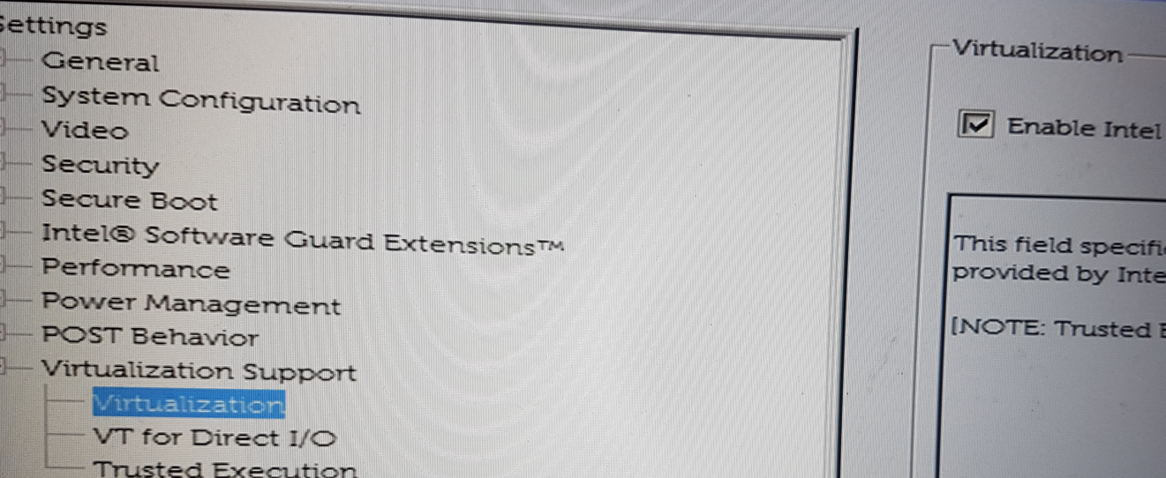

1. What type of **BIOS system** do you have?

BIOS/UEFI:

To find the amount of RAM (**physical memory**) that your laptop has installed.

* Go to **Start,** enter **System**, and then select the **System** icon.
* Look under **Installed Memory (RAM** to find out how much RAM is installed on your machine.

1. Installed memory ( Dynamic RAM): GB
2. Storage type and Capacity:

Hard drive or Solid State Drive:

Capacity: GB/TB:

To find out your hard drive (magnetic or Sloid State Drive) storage capacity, you can:

* Use the keyboard shortcut, **Windows key + E,** or tap the yellow folder icon in the taskbar.
* Right-click on the C:\ drive and select **properties**
* You can see the **capacity** of your hard disk:

To find out the **storage type** of your hard drive, you can:

* Press the **Windows** key, searching for **optimize** or **defrag** depending on your version of windows

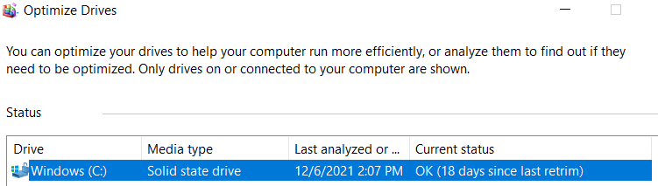

* Select the **Defragment and optimize** **drive** utility*.*
* Look under the **Media** type to find out if you have a **mechanical SATA** drive or a **solid-state hard drive**. If it displays **Hard Drive** then you know you have a mechanical drive. If the media type displaces **solid-state** then you know you have a solid-state hard drive.
* I have included an example screen capture below to help illustrate the difference between the hard drive types.

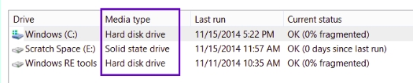

Figure 1. Media Types - hard drives.

1. USB Ports: How many: Type: example: 2.0/3.0 or C
2. VGA Port: Yes/No
3. HDMI Port: Yes/No
4. Web Camera: Yes/No
5. Microphone: Yes/NO
6. Ethernet port (RJ45): Yes/No
7. How to get your IP address?

Go to the search box/type CMD . Now right-click on the **command prompt** and choose **run as administrator**. You will see a black screen. At prompt type **ipconfig**



* 1. What is your IPv4 address?
  2. What is your WIFI IP address?

1. Microsoft Office or Office 365: Yes/No
2. Screen size **diagonally** (inch):
3. What are the **refresh rate and resolution** for the display?

Refresh rate HZ:

Desktop resolution:

To get to display resolution

Right-click anywhere on your desktop and choose **Display settings**. On the setting page, scrolls down and click on the **Advanced Display settings**.

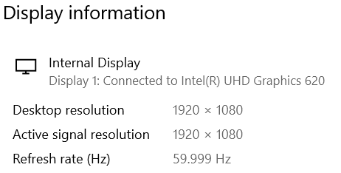

1. Laptop weight?
2. Miscellaneous – These are items/features that your laptop has but are not listed above:
3. Take a snapshot of your **Device manager**

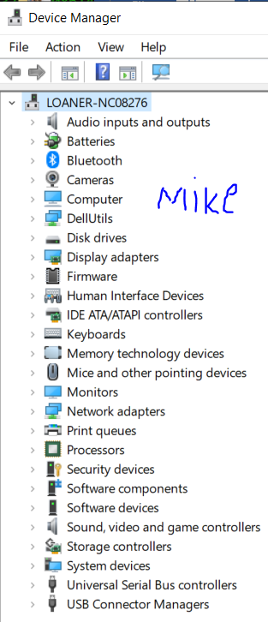

How to get to your **Device Manager** in Windows 10

Click on the **search** icon and type **Device Manager**

**Snapshot here (your name)**

1. Now that you have had your laptop for a while, what do you like about it? What do you dislike about it?

## CST8101 Check List

|  |  |
| --- | --- |
| **8 Marks**  **Mark** | All the questions are answered; verbally and written No missing answers (in Red) |
| **2 Mark** | Answers are easily understood by the lab instructor |
| **10 mark** | Total |